Case Study 6
Profile of M/s AAE
Name of the Enterprise | M/s AAE
Managing Partner | KP
Constitution | Partnership Firm
Factory Address | Sangareddy
Established | 2015
Line of Activity | Manufacturing of Readymade Garments
Udyog Aadhar
GST

- Line of Activity
The unit is primarily engaged in Manufacturing Readymade Garments suppling to schools, corporates against orders. Men shirts and trousers are also manufactured to sell in open market and through dealers.

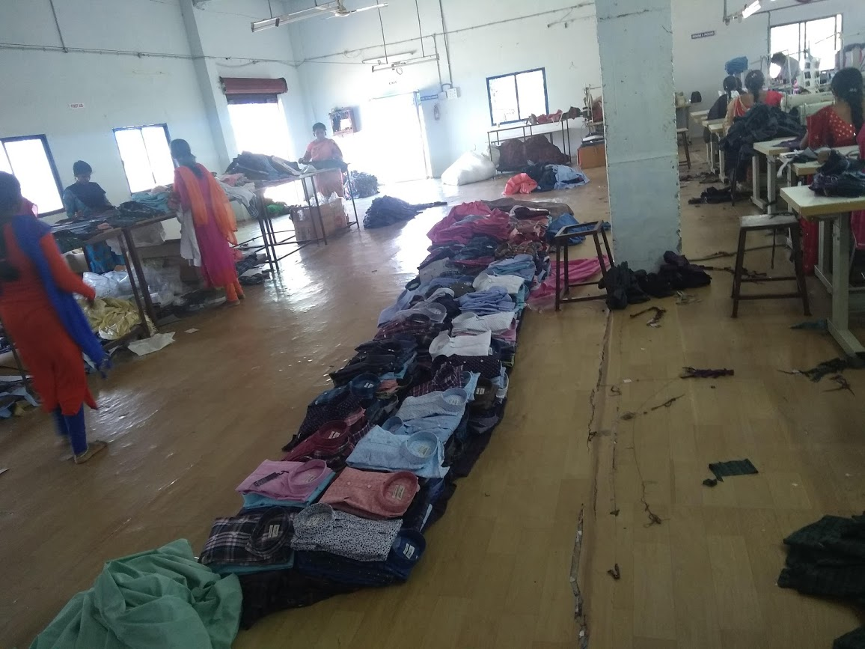

- Managerial Competencies
Smt KP, Managing Partner of the Unit has high involvement in the project as this being her primary source of income. She is first generation entrepreneur with good academic background. She is a member of Bharatiya Yuva Shakti Trust and has knowledge of the Manufacturing activities in the Garment Industry.

- Machinery
The firm has 35 sewing machines which are designed for detailing of garments, for button stitching, embroidery and other specifics required for garment industry
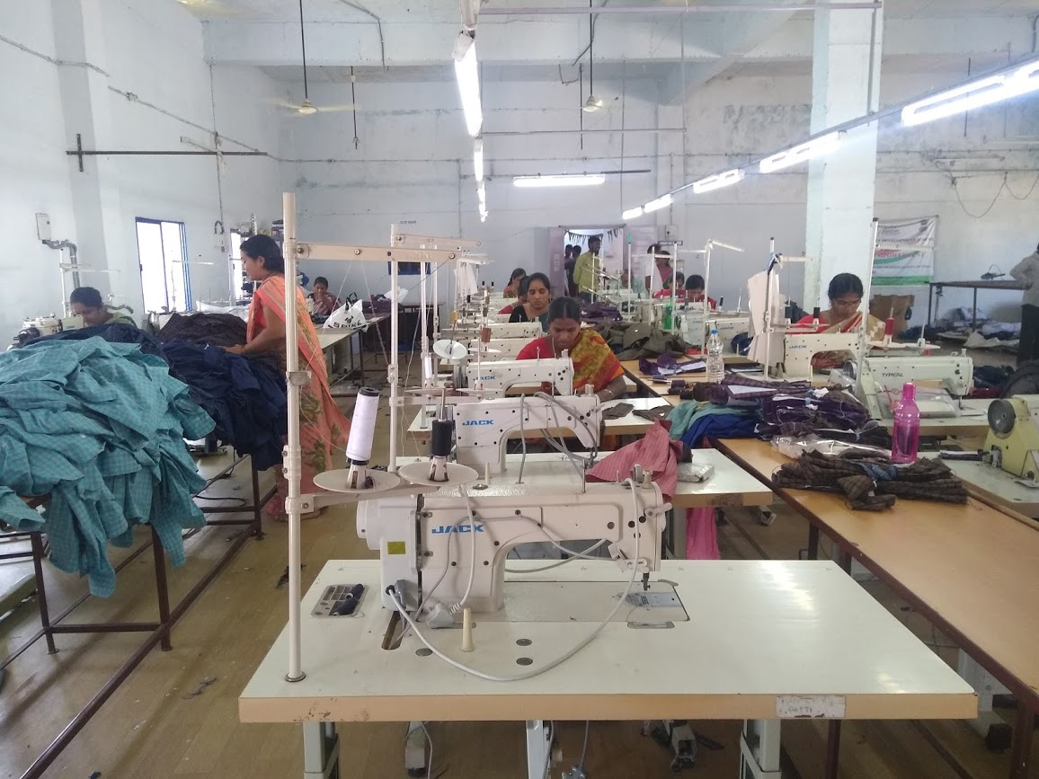

- Marketing
The unit has continuous orders from schools, offices, hospitals through established channels of below mentioned companies
1. DC
2. NLT
3. SI
4. SRE
5. UAE
- TIHCL Intervention
The unit was banking with Indian Overseas Bank, Balanagar Branch. The branch has extended Term loan and Working capital support aggregating Rs.10 million. The unit became sick and there were irregularities in the repayment schedule.

Client has approached TIHCL for priority release of sanctioned incentives to clear the overdues. The unit had sanctioned incentives aggregating to ₹ 5.0 million including investment subsidy of ₹3 million.

TIHCL has diagnosed the enterprise and identified following reasons of sickness
- Lack of financial control and burdened by term EMIs
- Locational disadvantage: The location was established in Textile Park promoted by state government which was in city out skirts. The commuting of the labour is a major problem.
- Non-availability of skilled labour
- The retail outlet at the Pashamailaram was not accessible to the general public.
- Lack the latest designs
- Limited exposure to business outlets
- Pricing the product in the competitive market
- Giving long credit period
Through TIHCL’s Bridge Finance against sanctioned investment subsidy the burden of repayment to the bank has been reduced which in turn helped the unit to make profits.

Key Indicators | Pre-Revival | Post TIHCL Intervention
No of EMIs pending with primary lender | 6 | 0
Capacity Utilization | 60% | 75%
Turnover | ₹ 15.3 million | ₹ 18 million (Annualised )
Employment | 35 persons | 35 persons

- Labour Status
Gender | Skilled | Unskilled
Men | 03 | 02
Women | 25 | 05
Total | 28 | 07

Livelihood: At 75% of the capacity they have employed 35 workers and their families are dependent on this enterprise which is around 175 individuals including entrepreneurs. The employed workers are sufficient to run at full capacity the idle time of workers will be reduced.

